Fun science for young primary pupils (differentiate by age).

Lesson 1: Air Almighty!
Aims and objectives of this lesson (which can be split into two or more sessions if necessary/desired)
Physical systems:  I have explored the forces from gravity  3rd cycle | - Describes how objects of different weight reach the ground at the same time though different speed  - Obtain information about facts and predict about natural phenomena.  - Make hypothesis about the result of experiments  - Communicate orally and write the results  - Work in groups being aware of own and others safety  - Make easy experiments concerning physics on different materials by:  presenting problems, suggesting hypothesis, selecting the necessary materials, reaching conclusions, exposing results and applying the basic laws that rule this phenomena  - Use the scientific method to plan and make projects, simple aparatus with the aim of leading to conciousness regarding self assessment

This lesson focusses on developing skills as described in the following list (Primary level 3rd cycle, year 5-6 in elementary ed Spain):

Forces, resistance  3rd cycle | By exploring the fall of different items,  I can use my knowledge of the properties of gravity to show how  it can be used in a needed situation. | - Demonstrates and records, through practical investigations, that objects of different weight reach the ground at the same time though different speed and that friction with air makes them fall slowlier  - Explains that we can make objects, persons resist the force of gravity by using resistance from friction  - Draws on findings from practical investigations to describe the effect of friction with air in order to refrain objects from falling fast

Risk assessment:

Pupils should not use scissors other than to make the parachutes. They should be supervised and warned.
The scissors should be used under supervision, it should not be used other than for experiment 3.
Pupils and teachers must wash hands carefully at the end of the lesson, and benches and equipment should be wiped with a suitable disinfectant before and after use.

Resources:

Per class, 6 sets:

Feathers, cloth, string, cork, balloons two sizes, scissors, golf ball, ping-pong ball, sticking tape

Timing: 10 minutes

Procedure/lesson plan

Experiment 1. Ball race? Guess which touches the floor first. Remember: Not the way to the floor, but pay attention to the arrival on the ground

Method:
The pupils work in group of 6.
Teacher Questions for pupils / Chat about balls
Q :who holds them ( A: sts). Q:Which is heavier/lighter? (Golf).. so which do you think will travel faster? And….will reach the ground faster?
Lets investigate if dropping two balls of different weigh have a different or same arrival to the ground
Teacher provides students with a ping pong ball and a golf ball. Students work in teams again. They have to assess the ball’s weight and make a guess on which one will fall faster, and have to think of an object that will fall slowlier and another that will fall faster than the balls.
Instruction to pupils: Now we are going to observe what makes objects fall faster or slowlier. What do you think is what drives objects? weight? shape?
Teacher Questions for pupils: what is going to happen?. Observe the two balls.
what is going to happen if you drop both at the same time from the same height?
Activities: Children work in teams, take the two balls provided and think of a couple of objects that they might use. When they are ready with the thinking, they will perform their experiment in front of the other teams and everybody will see the results.
Demo: If no group arrives at the idea of using a sheet of paper, then the teacher can finish this performance with a simple experiment: two pieces of paper, one is flat, the other one wrapped making a ball. Same weight. Which one will reach the floor in the first place?
Discussion: After the experiments, children will have observed that the weight doesn’t determine the speed with which an object reaches the floor. So now they have to discuss what is it. The teacher has to help them reach the conclusion that it is air friction that stops motion, and that without it objects reach the floor at the same time.
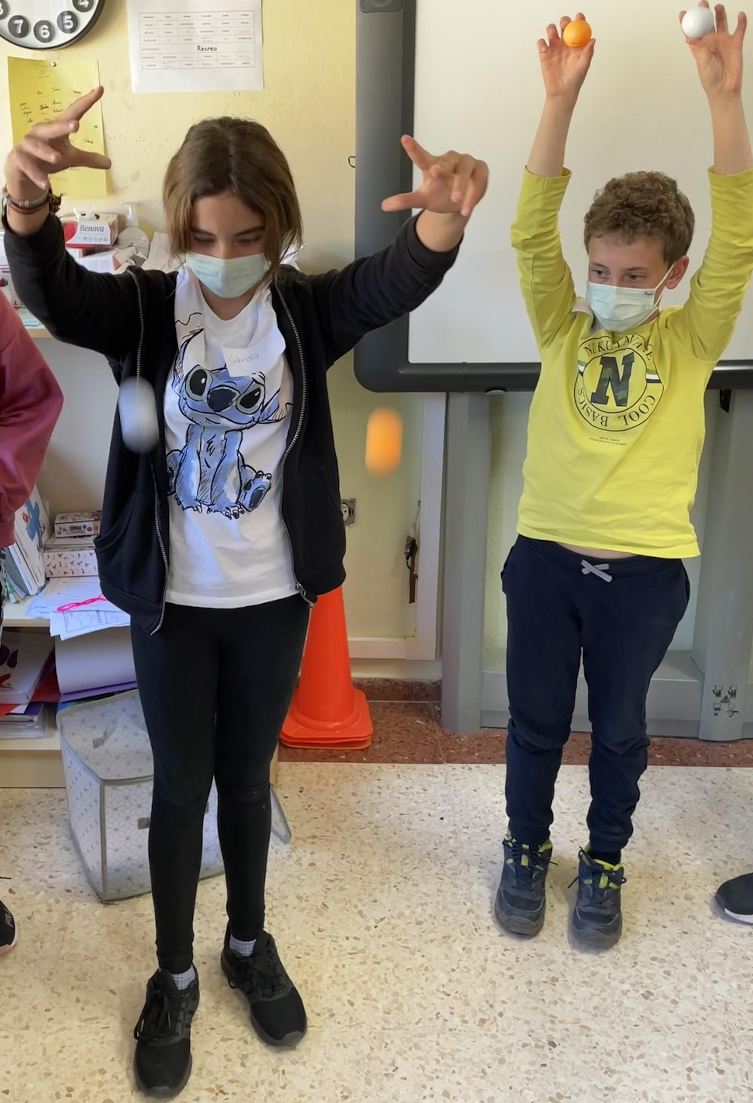

Experiment 2. Which ball reaches the floor faster?
Quick introduction to how objects fall/work using two pieces of paper. One shaped into a ball and the other flat.
Your eye is shaped like a ball with a hole at the front to let light in (Q: does anyone know which piece of paper will reach the floor faster? A: the pupil). When the same piece of paper has more obstacle from the air, it takes longer to fall onto the floor
See instructional video here:
Show animation/video toy story fragment (link below) of how the air works/how we resist from falling, people, paper… if the class is older/more capable.
https://youtu.be/-Np6YikhbTQ

Method:
Students should work in groups of 4-6. Designate a vocal and name the groups as they please

Teacher Questions for pupils (Q) ( A = answer)

Q: ask what they see it reaches the floor faster, or at the same time
Q: What do you think about the 2 exact pieces of paper reaching the floor differently?
One pupil from any group drops the 2 different shaped pieces of paper. Class poll should indicate that the ball of paper fell faster.
Questions: why did the ball fall faster? Answer to let more light in. Q: Does it have something to do with the shape of the paper?

Experiment. Plane flight

Method:
Procedure: The teacher makes a plane that is obviously a failure – Instead of a sharp tip in the front, it has some sort of flat surface that will blatantly collide with the air and it will prevent it from flying.
They should be able to guess that air stops the plane from flying further
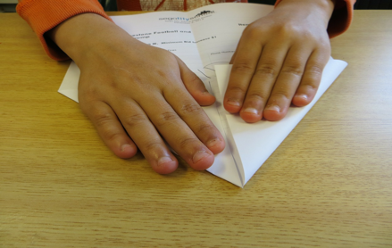
Question for the children: What do you think of my wonderful plane? Can you make a plane that flies better than mine?

Children then are invited to guess whether (and why) the teacher’s plane will fly better or, most likely, not at all. They might come up with the role of air in objects’ motion.

Experiment 4. Parachuting.

Method:
Teacher Questions for pupils
Q: how do people jump from planes safely? They use parachutes
Lets make our own parachutes using the resources in the box.

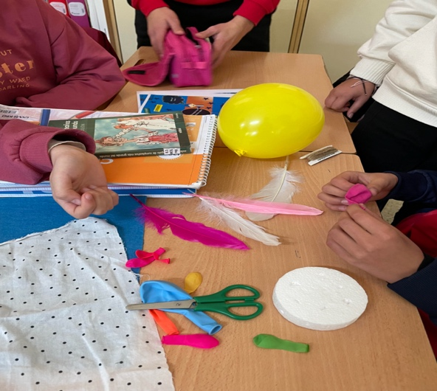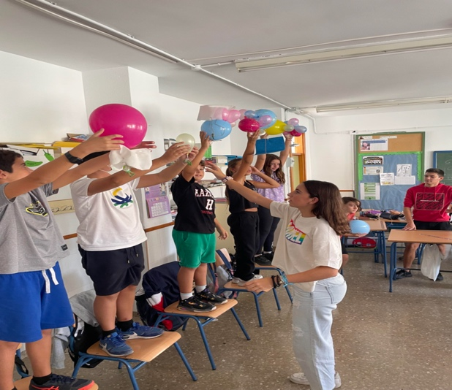

Each pupil figures a way to keep the soldiers safe when jumping using the material in their box. They all cooperate in giving ideas of how can they keep the soldiers safe when jumping

Teacher notes: Background science and resources for lesson

Power points that can be converted and edited as needed for different level students

1 Vocabulary

2 Explanation

3 Questions

4 Answers

Link for ppt folder

https://drive.google.com/drive/folders/1NaY5PWH23MaCOL0hyAV2V5TVjXqJ_xJr?usp=sharing

Description:

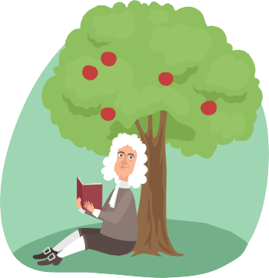
What is gravity?
Gravity is what keeps us from floating away in space. It’s what makes balls fall back down to the Earth after we’ve thrown them, what controls the tides of the oceans, and what makes the planets orbit around the Sun.
Gravity is a strong force that pulls things together. Everything that has matter generates gravity, from a tiny spec of dust to a huge elephant. You even generate gravity!
The bigger the object is, the bigger the force of gravity. That’s how the Sun can pull all the planets of our solar system close to it.
The closer objects are to each other, the stronger their gravitational pull is. The Sun has much more gravity than Earth but we stay on Earth’s surface instead of being pulled to the Sun. This is because we are much closer to Earth.

Who discovered gravity?
Gravity has always been around in the universe but no one really understood how it worked until the scientist, Isaac Newton, studied it mathematically in 1666.
It is said that his ideas about gravity were inspired from an apple falling off a tree and onto his head. This made him wonder what force made the apple fall downwards instead of floating up and away. He came up with a theory called Newton’s Law of Universal Gravitation and produced his own formula to know how strong it is. In physics, weight is measured in newtons, named after Isaac Newton.

Fun facts
- Black holes have the strongest gravitational pull in the entire universe.
- Gravity always pulls, it never pushes.
- In outer space there is zero gravity so you have no weight, this is how astronauts can float.
- Objects weigh slightly more at sea level than at the top of a mountain. This is because the higher you go, the less gravity pulls you.
- We don’t actually feel gravity. We can only feel the effects of trying to overcome it when we jump or fall.
- Every day we are about ½ inch (1.25 centimetres) taller in the morning than at night. This is because, during the day, gravity is pulling us towards the centre of the Earth. When we lie down our spine can stretch back to full height again.

