Lesson Title: Magnetism Pupil Age/Stage: 10-12
- Scientific Background
- No specific scientific background demanded of the pupils
- A background information sheet is available for teachers.
- The lesson is set up as an educational board game

- Aims and Objectives

This lesson focuses on developing skills and knowledge as described in the following list

  - Plans and designs scientific investigations and enquiries
Plan and purpose
- Raising interest in science
- Demonstrating science is not a distant memory
- Working together on a specific scientific concept idea or issue
- Formulating a hypothesis on a scientific question
- Drawing up a procedure for scientific research

- Primary 6/7: Collaborating with others to identify questions to find out more about a specific scientific concept, idea or issue.

2.2 Carries out practical activities in a variety of learning environments
- Identifies risks and hazards and ensures safe use of all tools, equipment and procedures.
- Collaborates to undertake investigations.
- Observes and collects information

2.3 Analyses, interprets and evaluates scientific findings
- Interprets findings and discusses links to the original question.
- Relates findings to their wider experiences of the world around them.
- Identifies and discusses additional knowledge or understanding gained information

2.4 Practical Science skills- the pupils should :
- have carried out a simple experiment in which they observe that magnets attract iron objects

have carried out a simple experiment in which they observe that like poles repel each other, and unlike poles attract
- have carried out a simple experiment from which pupils deduce that a compass is also magnetic
- pupils carry out an experiment in which they make their own compass needle
- have demonstrated the ability to predict, observe, and draw conclusions
- for a number of concrete applications, pupils can make the link between the observed laws (force effects between magnets and magnetism and geomagnetism) and the application

- Risk assessment:
- School/local Coronavirus rules for distancing, mask wearing and sharing resources should be followed. Pupils and teachers must wash hands carefully at the end of the lesson, and benches and equipment should be wiped with a suitable disinfectant before and after use.
- Children must be supervised using magnets and must be reminded not to swallow magnets, or place in their mouths. All magnets should be counted in and out so that none are removed from the classroom. Cracked magnets should not be used.
- If iron filings are used the pupils must wear goggles to prevent rubbing eyes with contaminated fingers
- Pupils with hearing aids have to bring a signed parental permission slip to show that parents are aware that their child will be using magnets, which can have an impact on hearing aids.
- Pupils should be told to check that all of the resources are present at the station when they first arrive at it, and teachers should check in all resources before releasing pupils at the end of the lesson.
- Be careful with the magnets, do not drop them
- Watch out with the fishing rod, don't hit your classmates

4 Resource Pack Contents

resources | 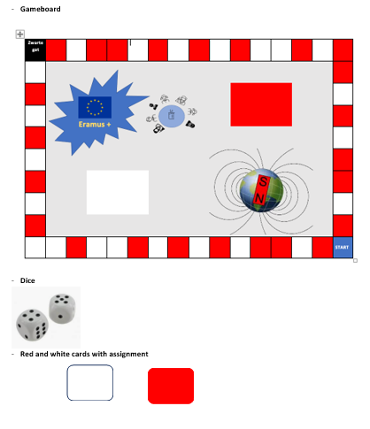  Content Box  - Gameboard  - 8 cards with experiments (4 white, 4 red)  - 1 dice  - Set of 6 game pieces  - Picture of a lion  - Iron fillings  - Needle  - Compass  - Petri-plate  - 4 round magnets with hole  - 2 round black magnets  - set of 2 bar magnets  - iron nuts  - 4 wooden sticks + cords (fishing well) to make fishing rods with the round magnets or little fish magnet  - picture of a lion (magnetic hairdresser)  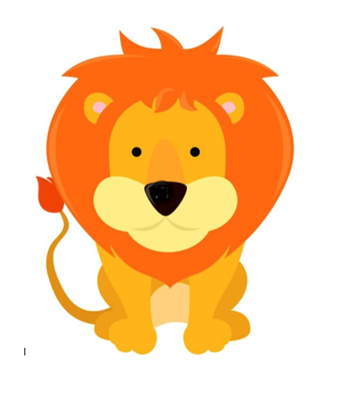  - Pc ,connection with internet  - Pptx magnetism

5 Experiment(s)

Title

Experiment 1/2/3/4/5/6/7/8/9/10

Timing

minutes

Number of pupils and of resources per group

4 or 5 pupils/ group

1 gameboard/ group

1 dice/group

4 of 5 game pawns/group

Description

This lesson is set up as an educational board game

Method including questions and answers
Before starting the experiments:
Pupils should be told to check that all of the resources are present at the station when they first arrive at it, and teachers should check in all resources before releasing pupils at the end of the lesson.

Experiment 1:

1.1 Material: two bar magnets
1.2 Method: bring 2 magnets closer to each other
- Approach a north pole with a north pole (red by red)
- Approach a south pole with a south pole (white by white)
- Approach a south pole with a north pole (white by red)
- Approach a north pole with a south pole (red by white)

1.3 Choose the correct answer

Same colors attract/ repel each other
Similar poles attract / repel each other

Different colors attract/ repel each other
Different poles attract/ repel each other

Experiment 2: magnetic board with metal pen

2.1 Material: magnetic drawing board with pen
2.2 Method
Make a drawing on the board.
Remove the drawing by using the eraser bar.

2.3 Explain now what happened.

2.2 Method
Make a drawing on the board.
Remove the drawing by using the eraser bar.
There are iron filings in the board and a magnet in the pencil which attracts the fillings.
The eraser is another magnet (a bar magnet) which draws all the filings to the edge of the screen
…
Experiment 3: magnetic barber

3.1 Material
- Lion picture
- Iron fillings
- Bar magnet

3.2 Use a magnet to give the lion a new haircut.

3.3 Can you explain how the barber magnet works?

The hairstyle (hair) made of iron filings is shaped by a magnet behind the drawin

………………………………………………………………………………………………………………………………………………

Experiment 4: magnetic field

4.1 Material

- Plastic folder
- Iron fillings
- Bar magnet

4.2 Method

- Put the bar magnet on the table.
- Cover with the plastic folder.
- Sprinkle the iron fillings on the folder.
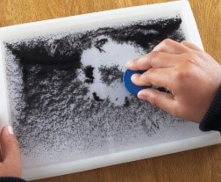

4.3 Draw what you see around the magnet.

Experiment 5: make a compass
5.1 Material
- Bowl with water
- Needle
- (bar) Magnet
- Compass

5.2 Method
- Rub a needle with a magnet about ten times. Be sure to rub each time in the same direction.
- Place the needle carefully in a bowl of water.
- Compare the direction of the needle with a compass. The needle will point ……………………

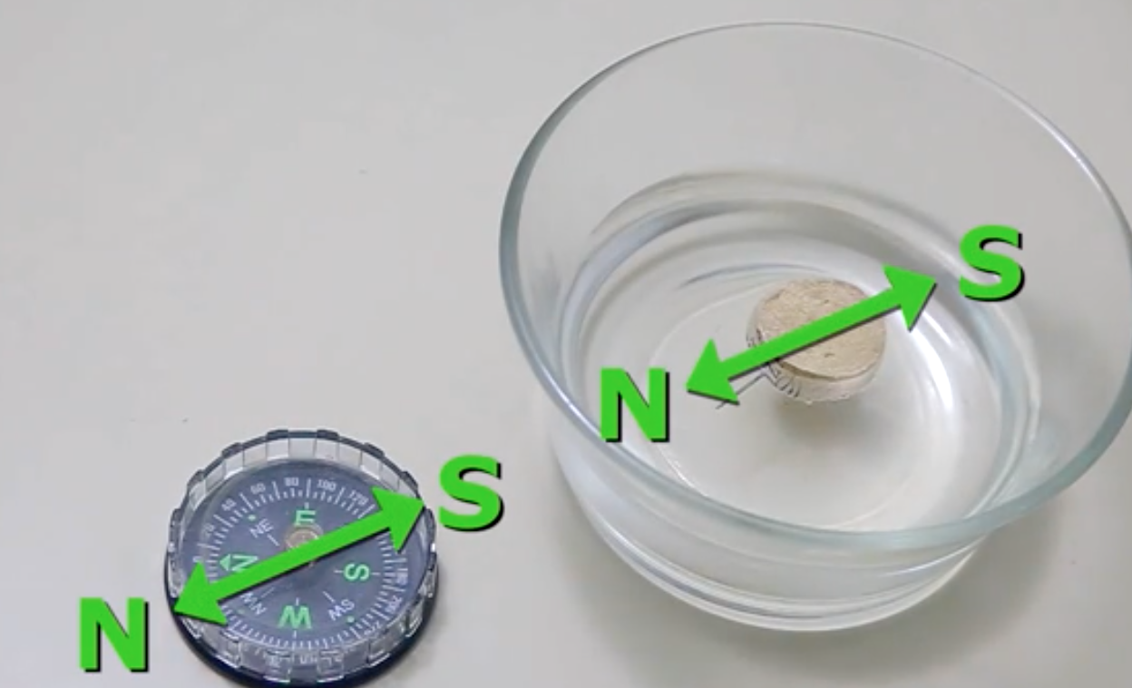

  - Where do you use a compass?

To point the north and to help the pirates

  - What does the compass indicate?

The north

  - We already found out that opposite poles attract. Remembering this, which pole do we expect to point north?

A south pole

Experiment 6: fish well

6.1 Material
- Fishing rod with magnet
- Various objects in a bin: coins, paper clips, toy jewelry, …
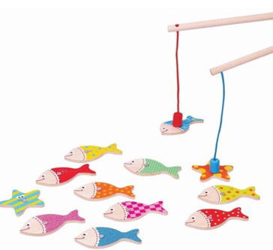

6.2 Method

Try to catch as much objects as possible.

Object | Magnetic | Non-magnetic
Copper coin |  | X
Steel coin | X
Paperclip | X
Piece of aluminium |  | X

6.3 Which materials are attracted to the magnet?
Objects containing iron and not too heavy

Ijzer, nikkel, kobalt, gadolinium

7.1 Material
- Plastic jar filled with oil
- Steel wool
- Bar magnet

7.2 Method

Use the magnet to create different shapes with the steel wool fragments in oil.

7.3 Observation: what happens when you approach the jar with a magnet?
`
All kinds of different shapes are created

7.4 How can this be explained?

The iron particles in the scouring sponge are attracted

Experiment 8

  - Material
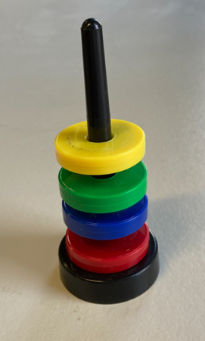

  - Method

Build a tower as high/low as possible with the coloured disks.

  - Can you explain how it is possible to build a high and a low tower with the same disks?
To build a tall tower, we make the cubes repel each other, to build a low tower we place the cubes so that they attract each other

Experiment 9: floating magnets

9.1 Material

-tripod
- two bar magnets

9.2 Method

Put both magnets in the tripod, once with both red/white ends above each other, once with unlike ends above each other.

9.3 Do you know where the principle of floating magnets is used?

…… Hover trains………………………………………………………………………………………………………………

Experiment 10: make a statue

10.1 Material
-Iron nuts and a magnetic plinth

10.2 Method

Create the tallest and most original statue

10.2 Who made the tallest figurine?

Lucy built the tallest tower

Discussion and conclusions

Conclusion 1

Magnets attract magnetic objects such as Iron, Nickel and Cobalt

Conclusion 2

Around a magnet there is an invisible magnetic field

Conclusion 3

A magnet freely suspended in the air rest in the North-South direction and the end that points to the North is called the North-Pole

Conclusion 4

Like poles repel, unlike poles attrack

Duplicate above as required

Summary of lesson findings

Additional resources

Videos

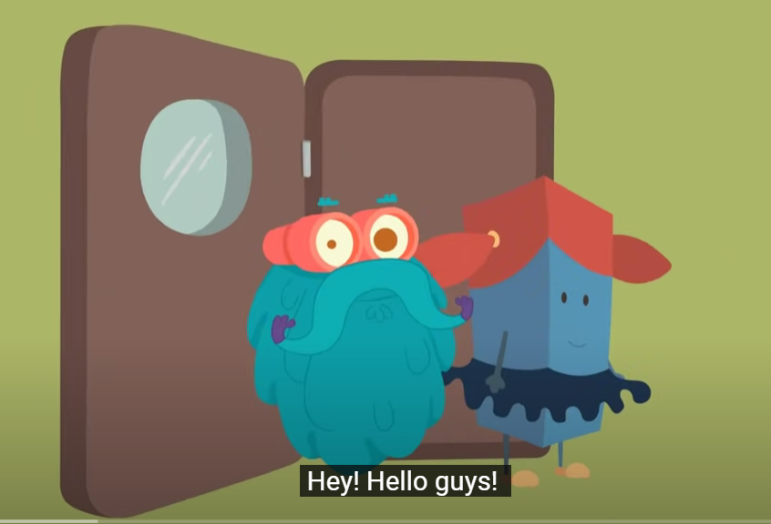

https://www.youtube.com/watch?v=yXCeuSiTOug

Worksheets

- Worksheet magnetism (on Teams)

- Worksheet fillid version (on Teams)

Powerpoints

Story books relevant to this practical

