Fun science for young primary pupils (differentiate by age)

Lesson 2: Pirate Pupils (The eye)
Aims and objectives of this lesson (which can be split into two or more sessions if necessary/desired)
Biological systems:  I have explored the structure and function of sensory organs to develop my understanding  of body actions in response  to outside conditions.  SCN 2-12b | - Describes how light enters the eye through the pupil and how the pupil changes size in dark/light conditions.

This lesson focusses on developing skills as described in the following list (first level benchmarks in Scotland):

Forces, electricity and waves  Vibrations  and waves | By exploring reflections,  the formation of shadows and the mixing of coloured lights,  I can use my knowledge of the properties of light to show how  it can be used in a creative way.  SCN 2-11b | - Demonstrates and records, through practical investigations, that light travels in straight lines an can be reflected by highly-polished surfaces  - Explains that we see objects because they give out or reflect light rays that enter our eyes.

Risk assessment:

Pupils should not move around wearing the eye patch in case they trip. If you need to move them to a different location for experiment 2 (a dark room is needed) do so moving as a group, walking very slowly and under supervision.

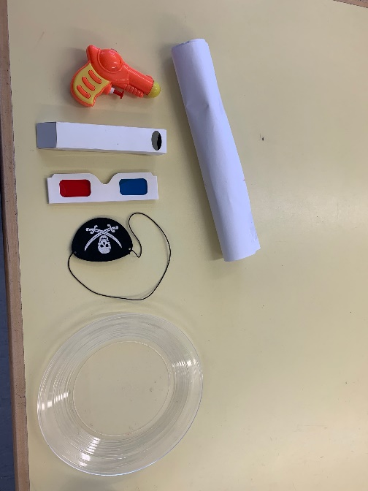
Resources:

Per class:

Powerpoint ( or you can print out images in colour if you cant show the powerpoint) Optional: One tennis ball
Per pair of pupils:
2 x eyepatches, 1 x periscope, 2 sheets of A4 paper,
2 x pairs of 3D glasses,

Procedure/lesson plan

Use PowerPoint provided

Experiment 1. How do we see?
Quick introduction to how eyes work – using diagram on powerpoint or board or a model if available.
Your eye is shaped like a ball with a hole at the front to let light in ( Q: does anyone know what the hole is called? A: the pupil). At the back of the eye are cells which can detect light. When the light comes in through the pupil it hits these cells they send a message to your brain and you can see the thing that the light came from/bounced off.
Video:
(Show animation/video of how the eye works/how we see if the class is older/more capable)
https://youtu.be/9OS-9pG1lT0?t=44

Method:
Students should work in pairs. Designate them as either partner A or B. They look in each others eyes.

Teacher Questions for pupils:(Q) = question ( A = answer)

Q: What do you see when you look at the other person’s eye?
A: A black circle. Q: What is it?/ do you know what it is called? A: Its called the pupil and it is a hole in the eye .
Q: What do you think its there for? A : to let light in so you can see).
One pupil from each pair looks at the light/window for a minute. When the teacher says “now” that pupil looks straight into the eye of the partner who decides whether their pupil got bigger, smaller or stayed the same. Class poll should indicate that the pupil got bigger.
Questions: why did the pupil get bigger? Answer to let more light in. Q: why did it get smaller when they looked at the light? A: because too much light might damage/hurt their eye.

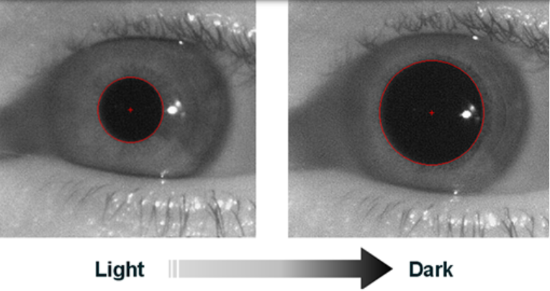

Experiment 2. One eye or two?

Method:
The pupils work in pairs. Each pupil places an eye patch over one eye. Explain that this will be for a really cool (sick) experiment in a few minutes but they must keep the patch on. They can check it is really blocking out all light by closing the uncovered eye and readjusting the eye patch until they can see no light at all.
Teacher Questions for pupils /Chat about eye patches
Q : Who wore an eyepatch ( A: pirates). Q: Why do you think they wore them? (usual answer: they had a damaged eye/it looked cool) Do you think ALL pirates had damaged eyes ( Probably not).. so why would they all wear eyepatches?
Pirates sometimes shot cannons or big guns at other ships ( could demo shooting water pistol at a cut out ship) … but then they ran out of gunpowder… where did they store gunpowder? A: below deck. Q: did they have lights down there? No.. so how could they see where the gunpowder was? Q : did they have torches. No. what did people use instead of torches in the old days? A: fire. Q.Could they look for gunpowder in the dark using a torch made of fire? No , the gunpowder would explode. So it was very dark… they had to be able to see in the dark..

Lets investigate if wearing an eyepatch helped them to see in the dark:

Method:

Take pupils into a dark room/ darken the room they are in as much as possible. They may have to go to a corner/cupboard/under a desk if there is too much light. The room should be so dark that they can see very little with their uncovered eye. They should look at a brightish light just before going into a dark room/darkening the room. They should then close their eyes, take the eye patch off and open only the previously uncovered (right) eye. The teacher should hold up a picture of something like a cannonball/gunpowder or alternatively could just hold up their hand.
Teacher Questions for pupils
.. Q How much can you see? Can you see this picture/ my hand? Then close the right eye and open the left /previously covered eye. Q : What can you see now? Can you see the picture of the… /can you find the gunpowder… A: Can see everything !!! WOW Moment!

Return to the classroom/ turn lights on. So do you think pirates wore eyepatches so they could see where the gunpowder was? Yes! IF your eyes are in the dark they start to make more of a chemical that lets you detect light. So your eyes get better at detecting really small amounts of light, and let you see in the dark.
Q: Did they keep the eyepatch on all the time?
Lets do some experiments to see how wearing an eye patch above deck would affect them.

Experiment 3. Far-away vision.
Teacher Questions for pupils
Q: How did pirates see ships when they were far away?
A: They had telescopes.

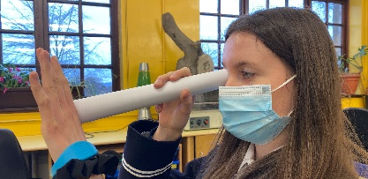
Method:
Lets make our own telescopes using a piece of paper.
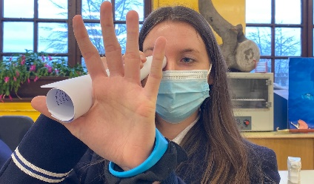
Each pupil rolls up a piece of A4 paper longways to make a long telescope. Each pupil holds their telescope in their right hand and looks through it using their right eye, keeping the left eye open. They bring their left hand up to the end of the telescope, palm flat, palm facing away from body, ( see photographs on the right) and see if they see a hole in their hands !!

This happens because their brains are putting the two different pictures from their two eyes together (-one eye sees the room through the telescope circle, one eye sees it without a circle so the brain sees a circle in the hand)..
our senses are tricking us…

So wearing an eyepatch to look through a telescope is a good idea-maybe THAT’S why pirates wore eyepatches! It made looking for ships much less confusing!

Experiment 4. Periscopes:
Teacher Questions for pupils
Q: How did the navy sneak up on the pirate ships to capture them , and not get seen by the pirates?A: They used submarines, and looked up through a long tube called a periscope…

Method:
Lets see if we can use a submarine periscope.
Show the pupils the periscopes and explain how they work.. Light travels in a straight line – it comes in the top and hits a shiny mirror so the light bounces to the bottom where a second mirror bounces it into your eye. The light is being reflected by the mirror.

One pupil in each pair gets a periscope and crouches down below desk level and sees if they can tell how many fingers their partner is holding up. Swap roles.

Experiment 5. Tricking your eye: Optical illusions.

Introduction:

The cells/detectors at the back of your eye can detect 3 colours: red blue and green. All the colours you see are made from a combination of these 3 colours, e.g. red and blue combine to give you pink (yes, its different with light than it is with paint!!)
Teacher Questions for pupils

How can we investigate this to see if it is true (Science is all about investigating to find out the facts!)?:

The pink elephant optical illusion – use Powerpoint
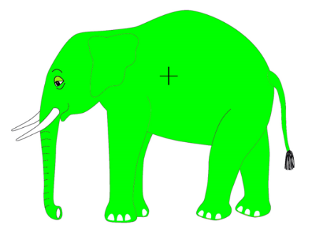

Method:

Pupils look at the image of a green elephant on the screen for 30 seconds, tell them they must not look away!! Count down with the class.

Now look at the white screen, Q: do you see a pink elephant??? Its just a white screen??? How can you see a pink elephant!?

Chat:

The parts of your eye ( receptors or ‘detectors’) that detect green light get tired out after 30 seconds so they stop working, now when you look at the screen you can see the after-image of the elephant but because only the red and blue detectors are working well you see purple (a mixture of blue and red)rather than white ( a mixture of red, blue and green light) .

Experiment 6. 3D glasses:

Chat:

Lets do another experiment using the red and blue detectors in your eye to trick your brain.

Method:

The pupils look at the first image in the powerpoint/printed 3 D picture and discuss what they see – blurry , red and blue pictures on top of each other but slightly offset …. Then they put on the 3D glasses and look at the images again.

Teacher Questions for pupils
Q: Does it look different? A: yes, it is clear and it looks 3D!
Discussion:

These glasses have one red and one blue (cyan) lens so your eyes see slightly different images. The 3 D picture you are looking at has a blue picture laid over the same picture in red so it looks a bit blurry… but when you put the glasses on each image is seen by a different eye – the red image by the eye with the blue lens covering it and the blue image by the eye with the red lens…. And your brain puts the two pictures together so you see in 3D.

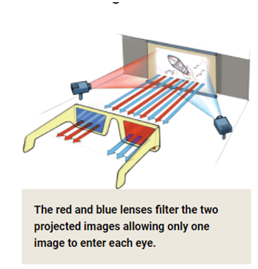

Teacher notes: Background science.

Understanding dark adaptation

Experiment 1:
When light levels fall your eyes will respond in two ways: the first and more visible of these is that the pupil in your eye expands in order to admit more light. The second change takes place in the retina.
In daylight the pupil is typically around 2 mm in diameter. In dark conditions the pupil expands to a diameter of approximately 5 mm in older adults and up to 7 mm in younger people, increasing the amount of light entering the eye by a factor of approximately ten times.

Experiment 2:
The expansion of the pupil takes place quite rapidly – typically in a few seconds. If you remain in dark conditions for long enough a second, slower change takes place, this time in the retina, which is the light-sensitive surface inside your eye. Over time the retina responds by producing more of the light-sensitive chemicals, increasing its sensitivity to light. It can take up to 20 minutes for this process to happen so it is important to be patient and allow time for your eyes to become fully dark-adapted.
Once in this dark-adapted state your eyes can be up to 10,000 times more sensitive to light than in normal daylight conditions. Exposure to bright light will rapidly reverse the adaptation, so to avoid spoiling your night-adapted vision and having to go through the process all over again, this should be done in a dark room.

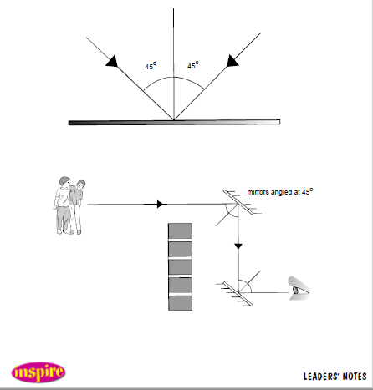
Experiment 5: How periscopes work:
Light enters the periscope, hits a mirror and is reflected onto a second mirror which reflects the light again – into our eye! See diagrams on the right.

