Fun with Fossils.
Aims:
The children should be able to:
- develop curiosity and understanding of the environment and their place in the living, material and physical world
- develop the skills of scientific inquiry and investigation using practical techniques
- state what a fossil is
- describe fossilisation

Materials:
Tray of sand containing a buried fossilised shell
A similar shell
Fossils Wooden spoon
Water Mixing jugs
Modelling clay Plaster of Paris powder
Safety spectacles Gloves (small)
Video https://www.youtube.com/watch?v=tyOjxjFHW-c
Or https://www.youtube.com/watch?v=Z4uEeslKTto
Safety: pupils do not handle plaster of Paris, it is prepared from powder (or outside room if pupil is asthmatic).
Lesson plan:
0-5 minutes: Discussion.
Discuss ‘What is old?’, children name items/people who are what they consider old. How old is the oldest thing they can think of? How would you handle something that was a million years old?
5-10 minutes: What is it? Intro to /recap on fossils
I tell the story of fossilisation using a tray of sand in which I have buried a fossil of a sea shell..I show how a similar shellfish could die , sink to the sea bed and be buried in layers of sand, pressure over millions of years could cause it to turn into….. .( reveal the fossil!)
Discuss what the fossilised shell is made of (stone); how did it turn into stone?; what do we call something that has turned into stone and is very old? A : fossils
Optional Watch video clip on fossilisation (cartoon)?
10-15 minutes: Different fossils:
We pass around a number of fossilised plants and animals , discuss what they are. E.g. megalodon tooth: must be at least 3 million years old. Why do some things fossilise and others not? E.g. dinosaur skeletons fossilise but we don’t often find fossils of their whole bodies, shell fossils are common but not fish fossils ( A: hard materials are more likely to fossilise and some animals and plants bodies did not fall where the right conditions were present for fossilisation to occur). Discuss how things turn into fossils (molds and casts)
15-30 minutes: making fossils.
The children press a fossil (or another object?) of their choice into sand or playdoh. I make up plaster of Paris in jug of 200ml water (add powder gradually, stirring all the time, until the powder forms islands when added ( any asthmatic pupils out of room). Add food colouring as desired to mixture.
We pour the plaster of Paris into the impression for them.
We will leave the ‘fossils’ to harden for at least 60 minutes after which the children can extract and keep them.

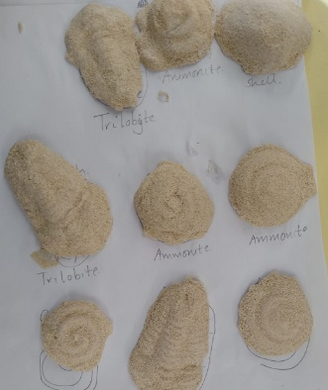

Optional extra:
Pupils make a model dinosaur foot out of Playdoh or similar home-made clay , and then press it into small dishes of liquid Plaster of Paris to make a cast of the footprint. These can be brought home as decorations! See photo below:

